DBMS LAB 10

Arshia Azeem 24k-0012
Q1:
a)
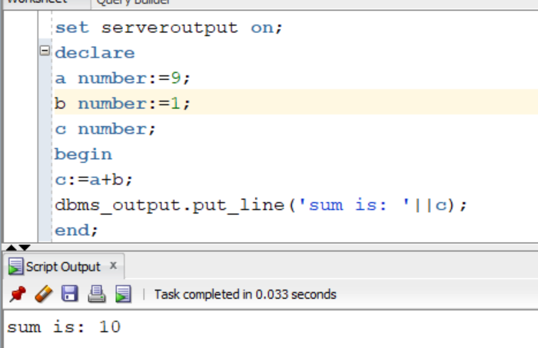
b)
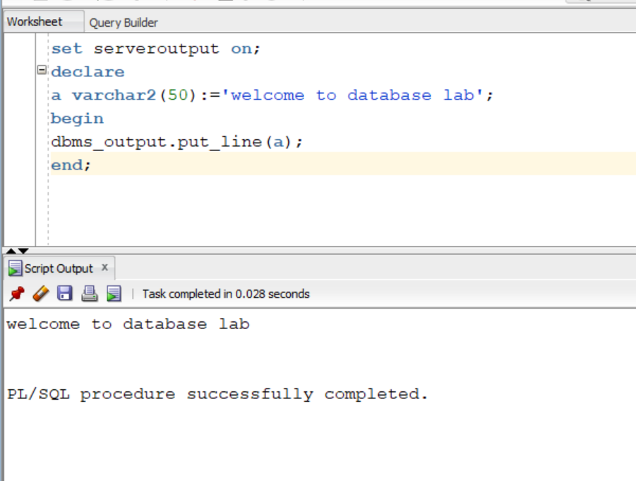
Q2)
a)
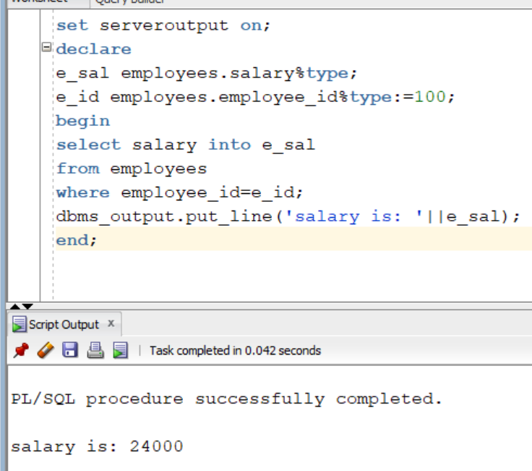
b)
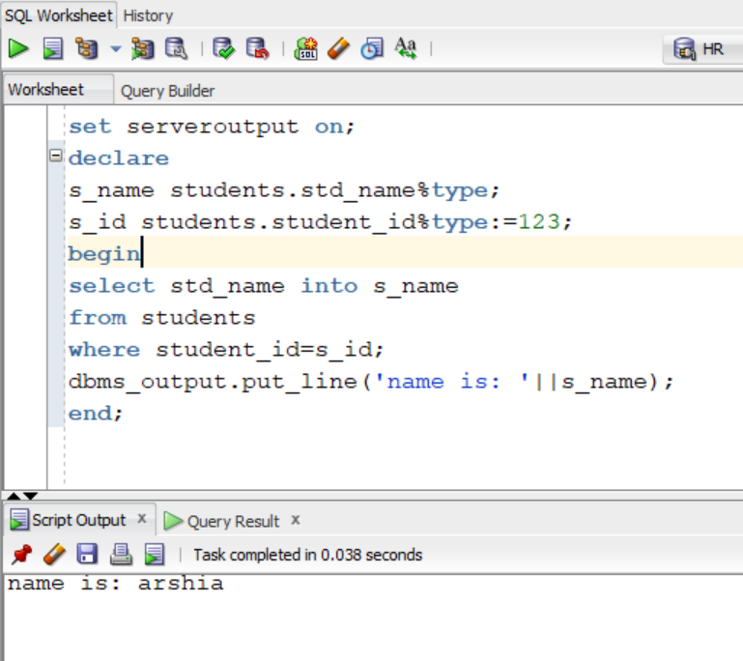
c) 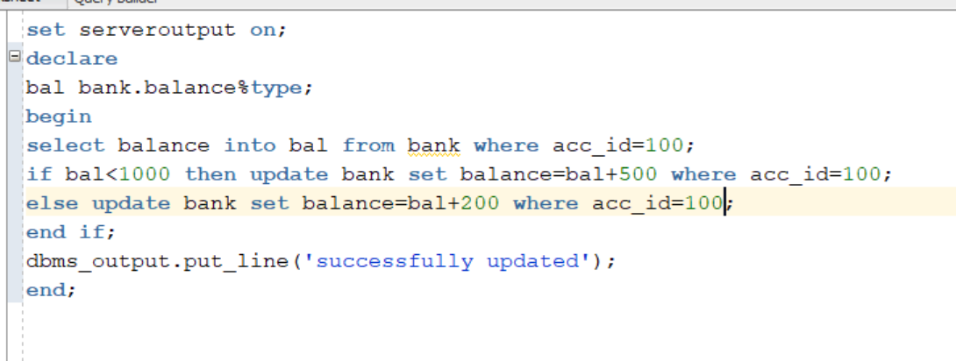
d)
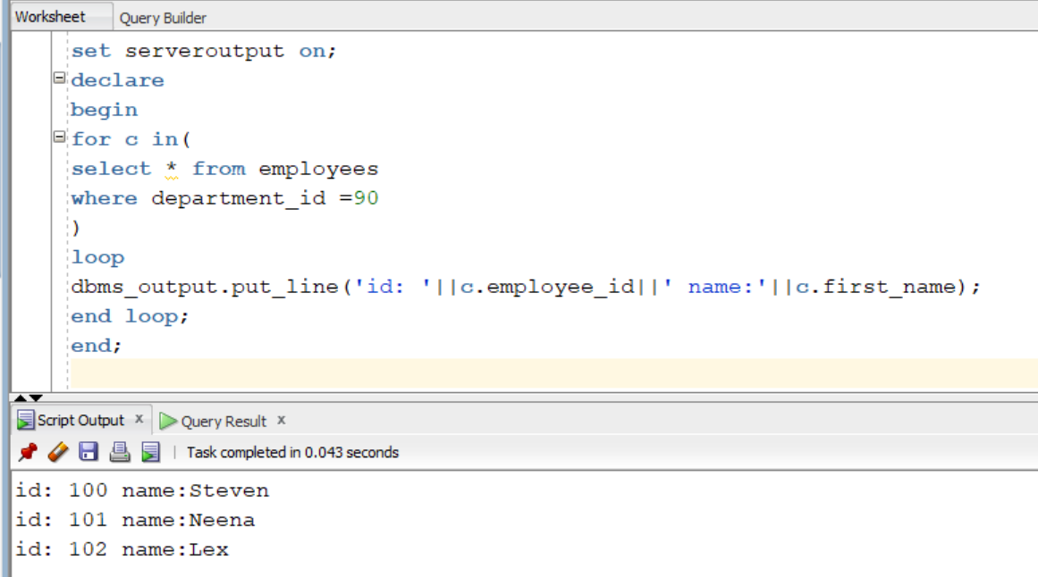
Q3)
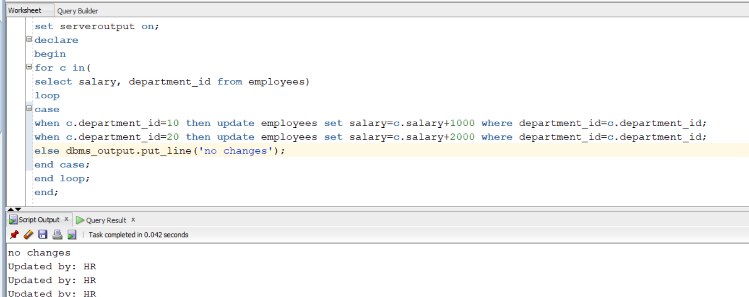
b)
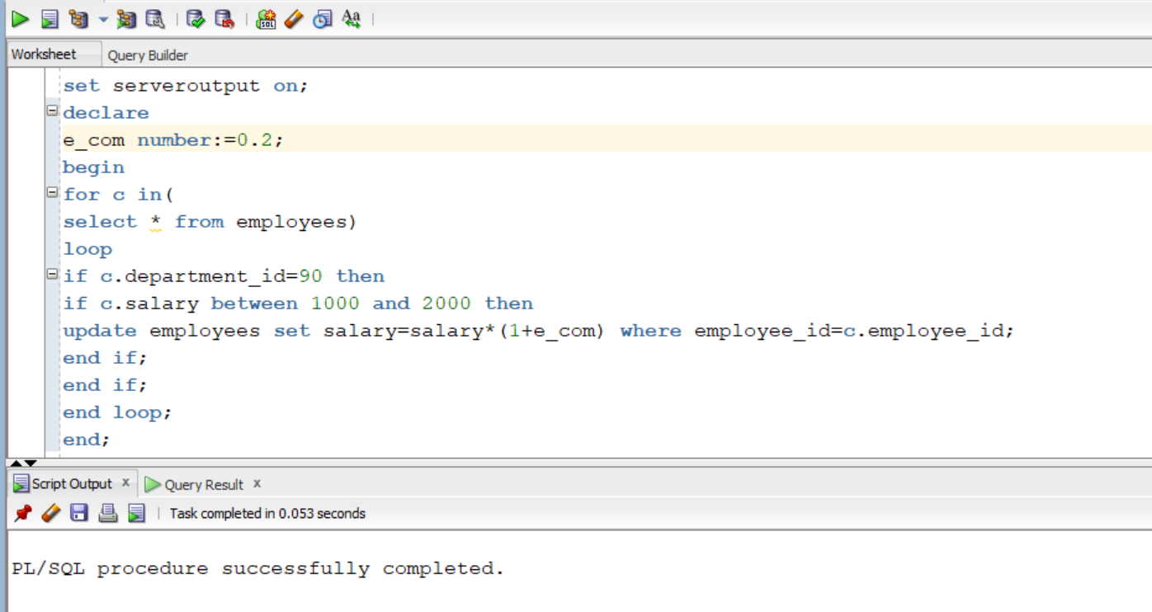
Q4)
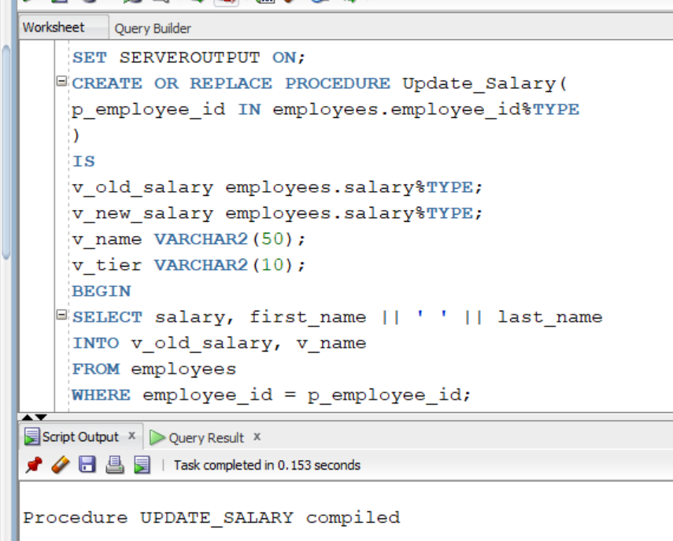
SET SERVEROUTPUT ON;
CREATE OR REPLACE PROCEDURE Update_Salary(
p_employee_id IN employees.employee_id%TYPE
)
IS
v_old_salary employees.salary%TYPE;
v_new_salary employees.salary%TYPE;
v_name VARCHAR2(50);
v_tier VARCHAR2(10);
BEGIN
SELECT salary, first_name || ' ' || last_name
INTO v_old_salary, v_name
FROM employees
WHERE employee_id = p_employee_id;
CASE
WHEN v_old_salary < 3000 THEN
v_new_salary := v_old_salary * 1.20;
v_tier := 'Tier 1';
WHEN v_old_salary BETWEEN 3000 AND 6999 THEN
v_new_salary := v_old_salary * 1.15;
v_tier := 'Tier 2';
WHEN v_old_salary BETWEEN 7000 AND 9999 THEN
v_new_salary := v_old_salary * 1.10;
v_tier := 'Tier 3';
ELSE
v_new_salary := v_old_salary * 1.05;
v_tier := 'Tier 4';
END CASE;
UPDATE employees
SET salary = v_new_salary
WHERE employee_id = p_employee_id;
COMMIT;
DBMS_OUTPUT.PUT_LINE('Employee: ' || v_name);
DBMS_OUTPUT.PUT_LINE('Tier: ' || v_tier);
DBMS_OUTPUT.PUT_LINE('Old Salary: ' || v_old_salary);
DBMS_OUTPUT.PUT_LINE('New Salary: ' || v_new_salary);
END;
/
Q5)
